Week –1

1.1

Key Topics: What is ServiceNow

Sub-topics: What is ServiceNow, its purpose, platform, and infrastructure

What is ServiceNow?

ServiceNow is a software Company based in Santa Clara, California, founded by Fred Luddy in 2003, to solve problems large enterprises face with traditional IT delivery by providing a robust, simple to use Cloud-based environment which businesspeople can use to solve the problems themselves. The company's core business revolves around management of "incident, problem, and change" IT operational events.

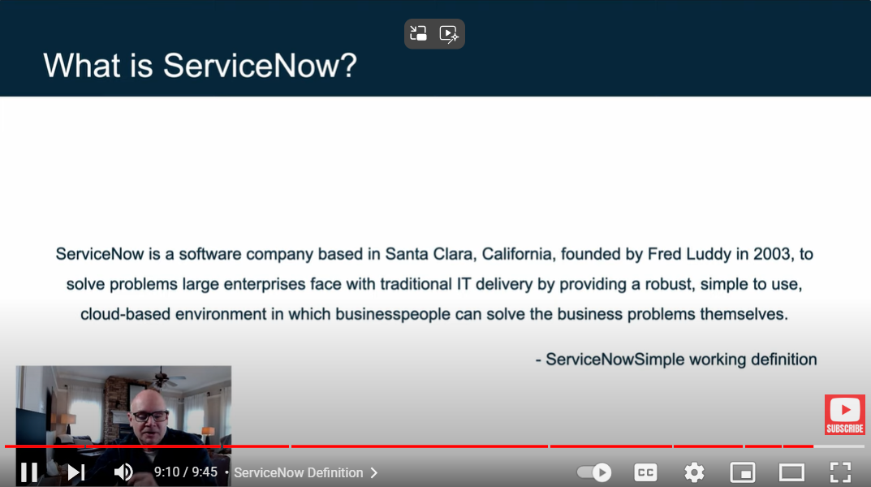

Purpose

ServiceNow is a cloud-based platform designed to automate and streamline organizational processes across various business functions. Initially focused on IT service management, it has evolved into a comprehensive enterprise service management solution that integrates multiple departments such as HR, customer service, security, and finance into a single, efficient workflow system.

Infrastructure

The ServiceNow platform's infrastructure is designed to provide a reliable, secure, and scalable environment that supports a wide range of enterprise service management needs. Its cloud-based architecture, robust security, and extensive integration capabilities make it a powerful tool for organizations looking to streamline and automate their operations.

1.2

Key Topics: ServiceNow Platform Overview

Sub-topics: ServiceNow Platform Architecture, Applications and Workflows, User Interfaces, and Role-based Access and Authentication

* Fred Luddy founded ServiceNow in 2004 to automate workflow across businesses. His motivation stemmed from frustration with business professionals being misunderstood by IT staff.
* Fred envisioned a platform where business professionals could solve their issues with intuitive technology without needing to explain their problems to IT staff.

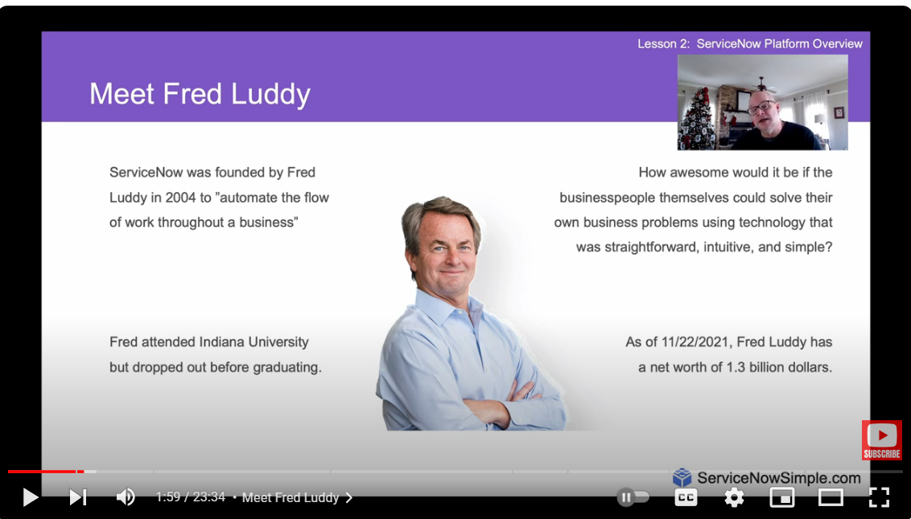

The Now Platform is described as an application platform-as-a-service (aPaaS). It integrates infrastructure as a service (IaaS), platform as a service (PaaS), and software as a service (SaaS). The platform provides all the required infrastructure and software management, allowing users to focus on building applications

* ServiceNow combines the three models (IaaS, PaaS, SaaS) into one comprehensive platform, providing cloud-based infrastructure, platform, and a suite of applications.
* The platform is built on a single shared database and data model, enabling integration and ease of use across different business functions. The platform provides all the required infrastructure and software management, allowing users to focus on building applications.
* ServiceNow utilizes an advanced, multi-instance, single-tenant architecture as the default offering for customers, meaning an instance features an individually isolated database containing data, applications, and customizations.
* The Platform integrates with other enterprise systems and supports a wide variety of plug-and-play applications.
* ServiceNow Provides a platform upon which you can build custom applications.
* All ServiceNow Data Centers are paired with another datacenter to provide redundancy. Redundancy is built into every Layer including devices and network resources
* Backups & Security - ServiceNow provides 4 weekly full data backups and 6 days of daily differential backups. The entire platform is secured using third party security organization. ServiceNow maintains high backup protocols for the safety of data and provides multi-user factors of authentication.

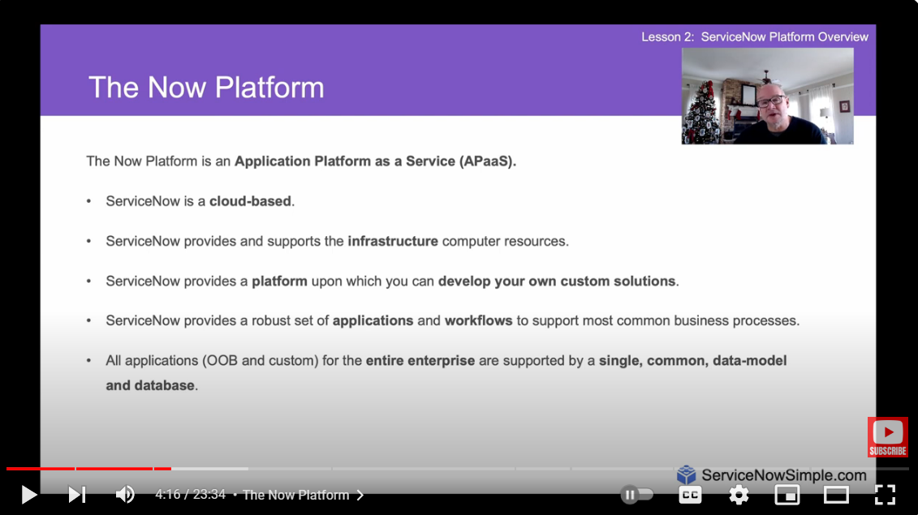

A workflow is a set of activities or tasks that automate a business process. Workflows help streamline processes, enforce business rules, and reduce the need for manual intervention. There are 4 primary Workflows in ServiceNow:

IT Workflow

Employee Workflow

Customer Workflow

Creator Workflow

IT Workflow

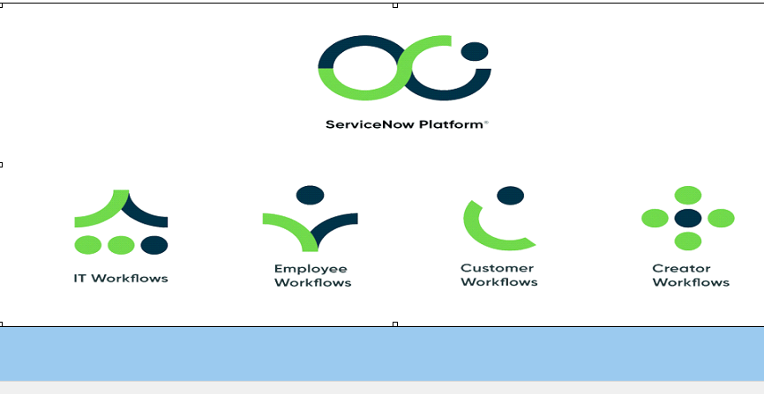

IT Workflow

* The IT workflow within ServiceNow is designed to streamline and automate IT service management (ITSM) processes, ensuring efficient handling of incidents, service requests, changes, problems, and other IT-related tasks.

Employee Workflow

* The employee workflow in ServiceNow is designed to streamline and automate various HR and employee-related processes, enhancing the employee experience and improving organizational efficiency. ServiceNow provides a centralized platform where employees can access services, request support, and manage their interactions with HR, IT, and other departments.

Customer Workflow

* Customer workflows in ServiceNow are designed to enhance customer service operations by streamlining processes, improving communication, and providing efficient resolution of customer inquiries and issues.

Creator Workflow

* Creator workflows in ServiceNow are designed to empower developers, administrators, and even non-technical users to create and manage custom applications, automate processes, and develop solutions that meet specific business needs.

Now Platform User-Interfaces

Now Platform UI - The Now Platform UI is primarily used on desktops or laptops, while the mobile apps address specific functions like request fulfillment and employee needs. These interfaces are designed to be user-friendly and efficient, helping everyone from regular employees to IT professionals, administrators, and developers get their work done smoothly.

ServiceNow Mobile Apps - ServiceNow provides several mobile apps that let users access the platform's features on their phones or tablets. These apps help employees, IT staff, and managers handle tasks, make requests, and find information no matter where they are. This means they can stay productive even when they're not at their desks.

Service Portal - The Service Portal is a user-friendly website where employees can easily find help and services they need. The Service Portal offers a customizable and user-friendly interface for specific user groups, accessible via a unique URL.

Role Based Access in ServiceNow

Role-based access ensures that applications can identify users and control their access based on their roles, using entities like users, groups, and roles.

USER – Users are assigned to groups and multiple roles to determine what they can access and do within the platform.

A user is represented as a record in the **sys_user** table.

GROUP- A Groupis a collection of users who share a common purpose or responsibility, such as being part of the same department or team. Groups help manage user permissions and workflows more efficiently. Instead of assigning roles to individual users, roles can be assigned to a group, allowing all members of the group to inherit those permissions.

This concept of a group is stored as a record in the **sys_user_group** table.

ROLE – A Role is like a set of permissions that decides what a user can do and see in the system. Roles are assigned to users to manage what they can access, and they help set up rules for who can do what in the system.

All roles are listed in the **sys_user_role** table.

USER AUNTHENTICATION

When a user logs in to an instance, ServiceNow validates their identity and enables access to applications and modules based on their roles and groups. It supports multiple authentication methods, including local database authentication, external SSO tokens, LDAP, OAuth 2.0, Digest token and multi-factor authentication.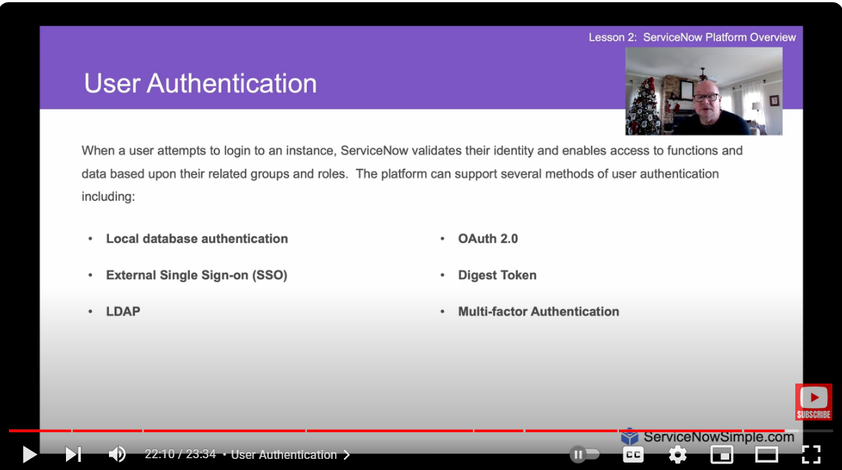

1.3

Key topic: ServiceNow User Interface Overview

Subtopic: ServiceNow Platform User Interface, Fundamentals Lesson, identifying elements of the interface, Global Search, Connect Chat, Contextual Help, Application Navigator, Favorites, History. ACLs, UI policies, Business Rules and Client Scripting

There are 3 main screen elements: -

1. Banner Frame

2. Application Navigator

3. Content Frame

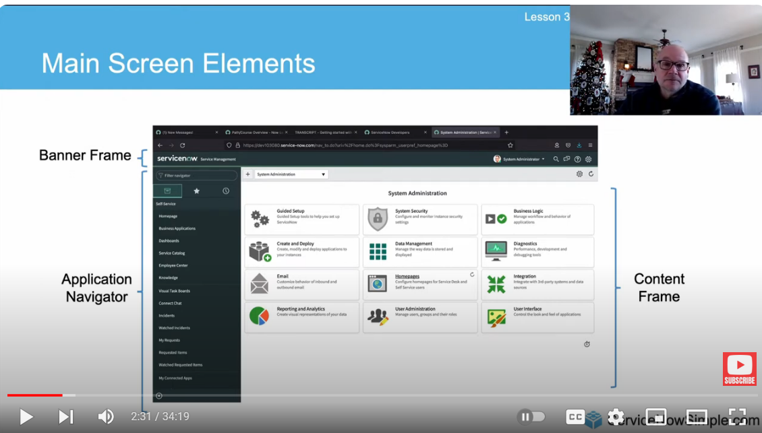BANNER FRAME

Banner Frame: User Menu

User Menu contains:

1. **Profile:** Profile settings allow users to change personal information such as name, phone, date format, email, and time zone.
2. **Impersonate User:** Impersonation feature is available for administrators or impersonators to view the system as another user, useful for troubleshooting.
3. **Elevate Roles:** Role elevation is a security mechanism for high-impact actions, requiring administrators to elevate their roles temporarily.
4. Logout: Logout option in the user menu to exit the ServiceNow instance.

Banner Frame: Tools

There are 3 main tools:

1. Global Search: It is used for searching records.
2. Connect Chat: It is used for real-time messaging.
3. Contextual Help: It is used for assistance based on the current context.

Banner Frame: System Settings

1. General settings include options to compress the UI, enable/disable keyboard shortcuts, and set the home page link.
2. Theme settings allow users to change the color scheme of the interface, useful for distinguishing between different instances.
3. Menu settings control the appearance of data lists and long text wrapping in columns.
4. Notification settings manage the types of notifications received and their delivery methods, while developer settings include options for application scopes and update sets.

Content Frame:

The **Content Frame** is the main part of the ServiceNow screen where you see and interact with information. Here, you can work with forms, lists, dashboards, reports, and other data related to the app or module you're using. It’s where most of your work gets done.

Application Navigator:

* The Application Navigator in ServiceNow is a component located on the left side of the interface that provides a way for users to quickly access different applications, modules, and functionalities within the platform.
* Applications are the Collection of files and data, they serve as the building blocks for delivering services such as IT, HR resource management, Service Desk etc. Modules are the individual functionalities or operations available under each Application.
* We can Pin the Applications and modules to favorites for quick access. We can use the Favorites to mark the application that we frequently use and have quick access to it. We also have a history option to look at our recent actions. Default is last 30 items we have accessed

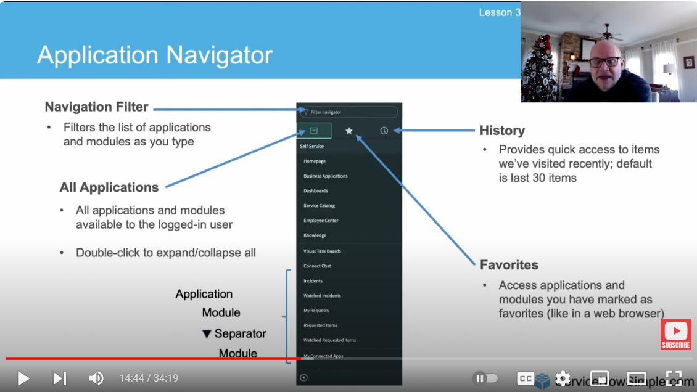

1.4

Key topics: ServiceNow Branding Overview

Subtopics: ServiceNow Branding Introduction, Company Guided Setup, ServiceNow Portal, and UI Builder

Branding in ServiceNow

Branding in ServiceNow aims to make the user interface reflect your company's identity, increasing user comfort and adoption.

**Guided Setup**

* **Guided Setup** in ServiceNow is a tool that helps administrators set up and customize their ServiceNow instance step by step. It provides a structured process with helpful tips and best practices to ensure everything is set up correctly.
* It covers various areas like setting up your company details, managing incidents, problems, changes, and service requests, and organizing your configuration items and knowledge base. It’s like a guided tour to make sure everything is done right.

ITSM Guided Setup

Customization like changing logo, company name can be done using the system properties

ALL - System Properties - System Configuration - Set timezone,date, color

ALL - System Properties - My Company - UI Banner - logo - Banner Text

All the properties are a table in ServiceNow, so these properties come under sys_properties table 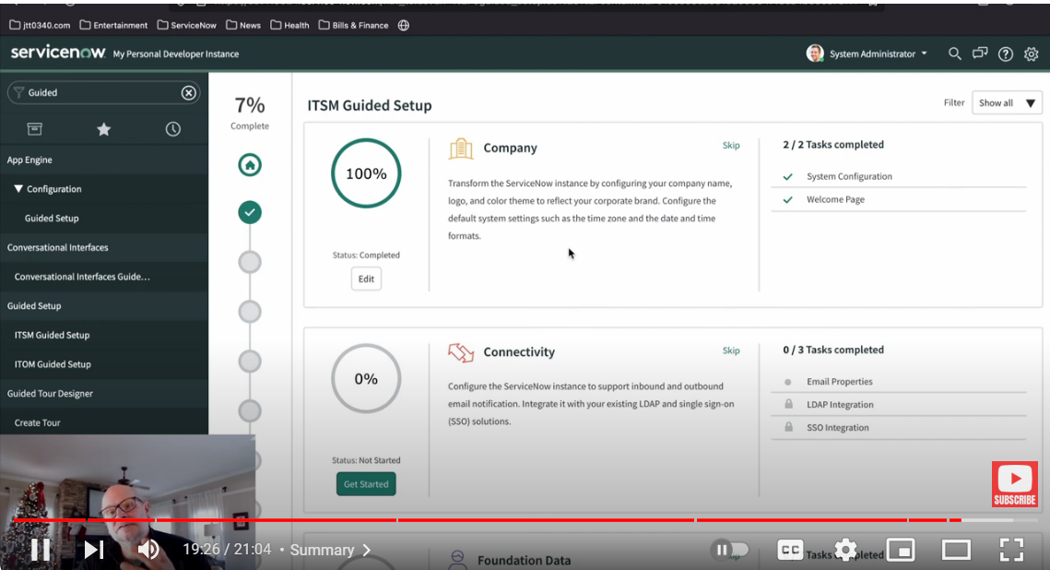

1.5

Key topic: ServiceNow Lists and Filters

Subtopics: ServiceNow List View interface, standard paradigm, List Control, filter conditions, Refresh list

**Lists** show records from a table in a grid or table format, making it easy to view, filter, and sort multiple records at once. Each database table in ServiceNow has its own list view.

You can access lists in three ways:

1. **Application Navigator:** Navigate to the list through the application navigator by selecting the appropriate module.
2. **Dot List Command:** Use the dot command (e.g., incident.list) in the application navigator to quickly open the list.
3. **Sys_db_object Command:** Use the sys_db_object.list command to see a list of tables, then select the one you want.

Using Table_name.list opens the list view of a specific table, and Table_name.LIST will open it in a new tab.

The **List Header** in ServiceNow provides several tools to help you manage and interact with lists:

* **List Controls:** These are options for actions you can take on the list or its items.
  + **List Control Menu:** Includes options like changing views, applying filters, grouping items, refreshing the list, and creating favorites.
  + **Column Option Menu:** Lets you configure the column settings, import data, create reports, and sort the list.
  + **List Field Menu:** Used to copy the **sys_id** of a record, which is a unique identifier in ServiceNow.
* **Filter Lists:** Allows you to search and apply filters to narrow down the list of records.
* **Table Search Bar:** Enables you to search for specific records within the list.
* **Personalize Icon:** Lets you customize the list view to fit your preferences.

VIEW

**Views** in ServiceNow allow you to display the same list or form in different ways, making it easier to focus on the information you need. System administrators can create custom views for both lists and forms.

How to create a new view:

1. **Select the Control Options Menu:** Click on the control options menu in the list or form.
2. **Go to Configure:** Choose the "Configure" option.
3. **Choose List Layout:** Select "List Layout" to set up the view for a list.
4. **Select Fields:** Use the list collector to choose which fields to display.
5. **Scroll Down and Select View:** Scroll down to find the view options.
6. **Create a New View:** Click "New," enter a name for the view, and save your changes.

To see and switch between views:

* Go to the **List Control Menu** and select **Views** to choose from the available views.

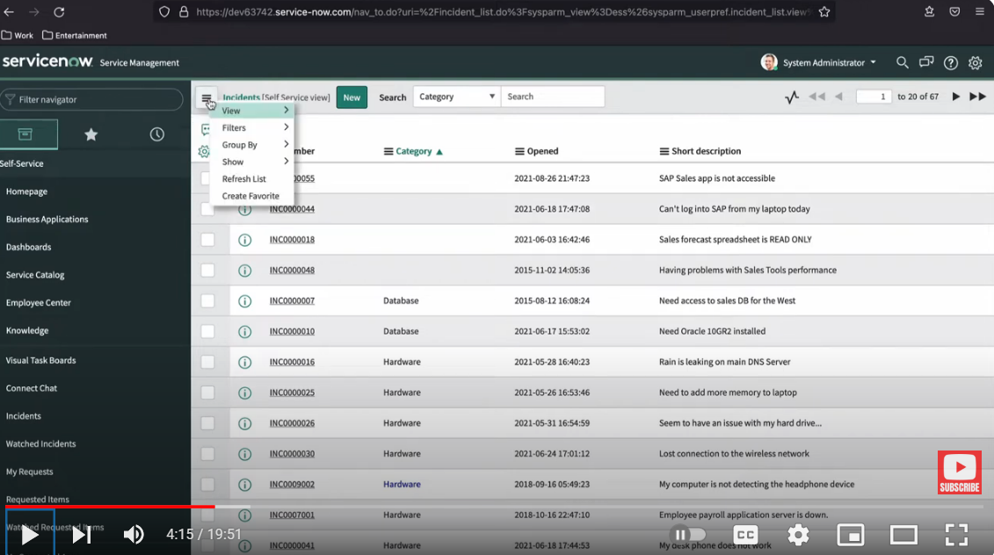Filter

A **filter** in ServiceNow is used to narrow down the data in a table list by applying specific conditions. Here are the three main parts of a filter condition:

1. **Field:** This is the specific data field you want to filter by. It includes options from the table you’re working with and can also include fields from related tables through dot-walking.
2. **Operator:** This defines how the filter should compare the field’s value. The options vary depending on the type of field you are filtering (e.g., “is,” “contains,” “is greater than”).
3. **Value:** This is the criteria you are looking for in the field. It can be a text entry or a choice from a list, depending on what type of data the field holds.

### Steps to Create a Filter in a List

1. **Open the List:**
   * Navigate to the list where you want to apply the filter (e.g., Incidents, Change Requests).
2. **Access Filter Options:**
   * Look for the **Filter** icon or menu, usually located in the list header. It might look like a funnel or be labeled “Filter.”
3. **Create a New Filter:**
   * Click on the **Filter** icon or menu, then select **Create Filter** or **Add Filter Condition**.

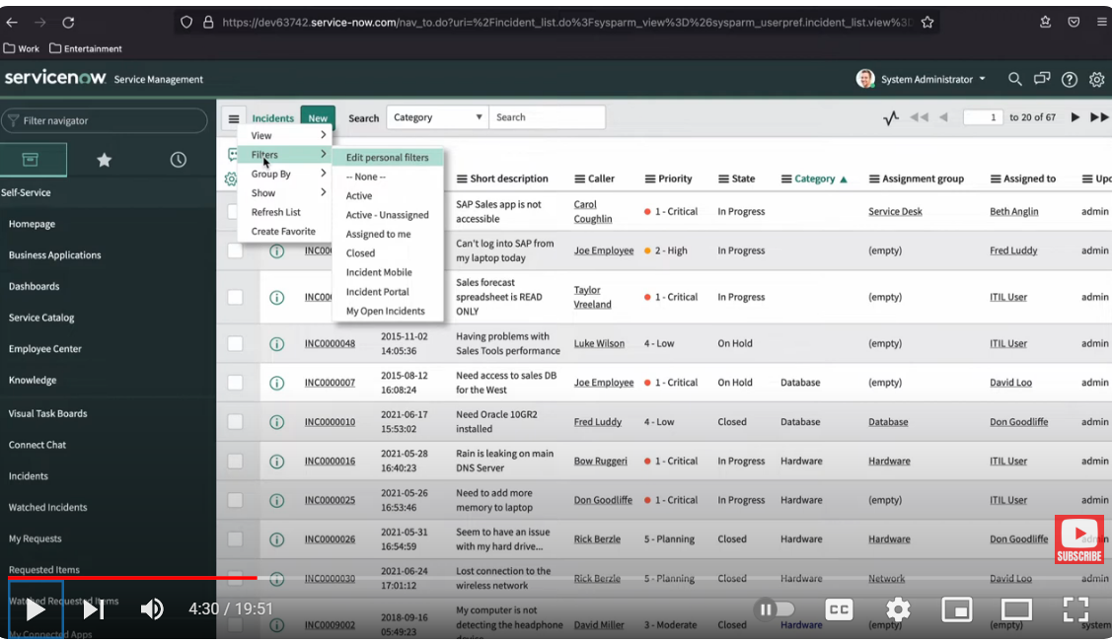

Breadcrumbs

The Breadcrumbs Filter conditions applied to the list are summarized in the breadcrumbs, shown in blue letters across the top of the list. Not only do the breadcrumbs provide an “at-a-glance” view of the filter’s conditions, but they allow you to modify conditions as necessary. For example, you can select the greater than sign before a condition to remove that condition or select a breadcrumb to remove all of the conditions that follow. Group By - It is used to group the list records based on a field. Refresh List - Used to refresh list to reflect the recent changes.

**Group By:** This feature allows you to organize the list records based on a specific field, grouping similar records together for easier viewing.

**Refresh List:** Use this option to update the list and reflect any recent changes or updates.

**List Personalization**

**List Personalization lets** you customize how a list appears for your own use without changing the default layout for everyone. Here’s what you need to know:

* **Personalize List:** This feature allows you to adjust the layout and display of a list just for yourself. These changes are specific to your user account and don’t affect how others see the list.
* **Temporary Customization:** Personalization's are meant for temporary adjustments. If the system or admin makes global changes to the list view, you won’t see those changes in your personalized list until you reset it.
* **Reset to Column Defaults:** If the system administrator updates the default list view, you won’t see these updates until you choose to reset your personalized list to the default settings.

**List Layout Configuration**

**List Layout Configuration** in ServiceNow involves adjusting the columns or fields displayed in a list view. This is typically done by administrators and affects how all users see the list. Here’s how to configure the list layout for a table:

1. **Navigate to the List:**

* Go to the list you want to configure and make sure you’re viewing it in the correct mode or view.

1. **Access Column Options Menu:**

* Click on the options menu for any column in the list (usually represented by a gear icon or similar).

1. **Configure the List Layout:**

* Select **Configure** from the menu.
* Choose **List Layout** to open the configuration options.

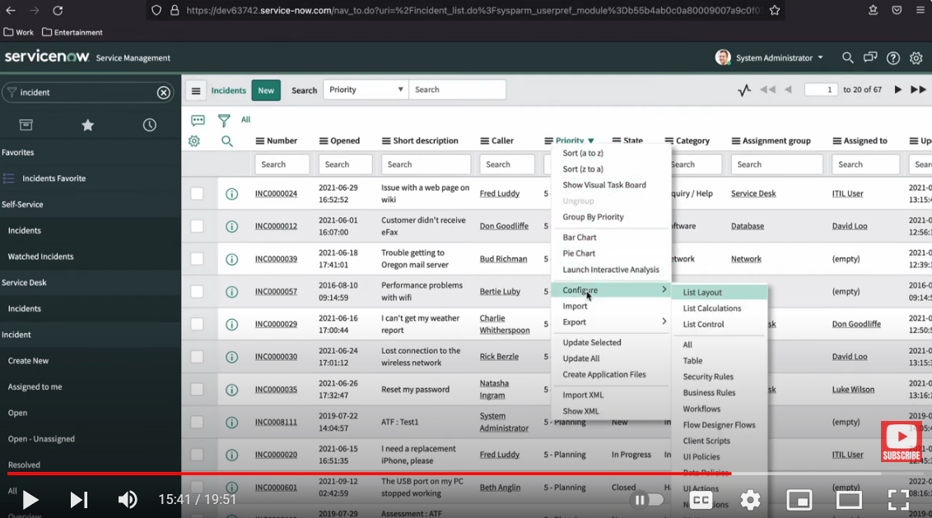

1.6

Key Topics: Forms in ServiceNow

Subtopics: Forms in ServiceNow, The Standard Layout, Form Field Types, Saving Changes, Insert / Insert & Stay, Form Sections, Related Lists & Formatters, Form Views, Form Personalization, Adding Attachments, Form Templates, Creating & Editing Views

**Forms** are user interfaces that allow you to view, create, and edit records in the database. Each record type is linked to a specific table, and there are thousands of forms available to manage the extensive data structure within ServiceNow. Forms help users interact with and manage data effectively by providing a structured way to input and display information.

The standard Layout

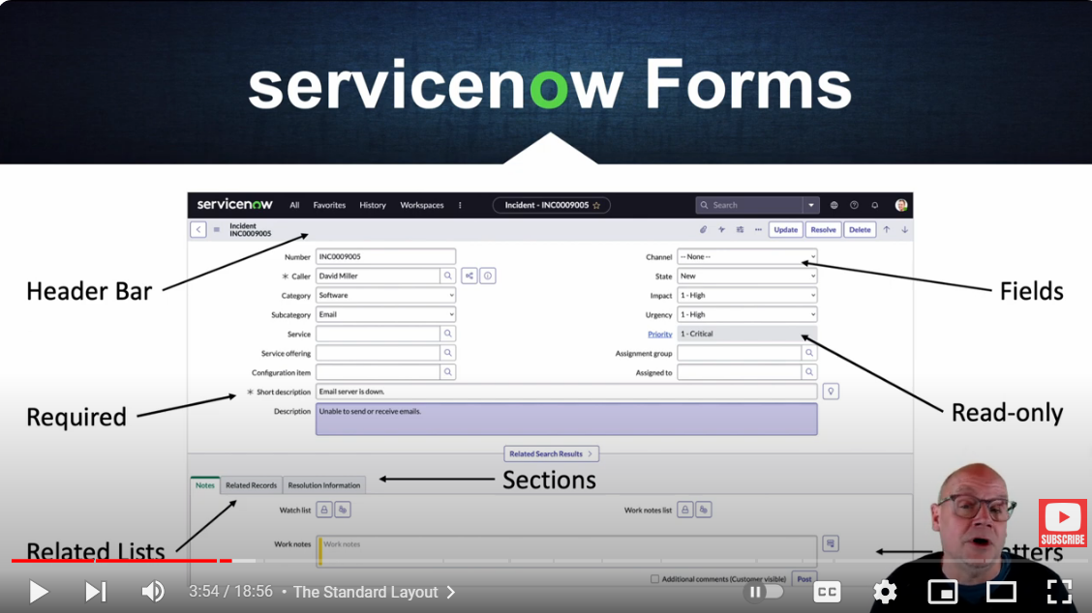

Header Bar:

* The **header bar** is the section at the top of a form or list that provides key information and controls related to the record or list.

Read-Only Fields:

* These fields display information that users cannot edit. They are often used for data that should be viewed but not changed, like record IDs or system-generated timestamps.

Required Fields:

* These fields must be filled out before the form can be saved or submitted. They are marked with an asterisk (*) or other indicators to show that they are mandatory.

Sections:

* Organize fields into logical groups to improve form readability and usability.

Formatter:

* Displays additional information or instructions that aren't part of the standard fields.

Related Lists:

* Show records from related tables that provide context or additional information about the current record.

Fields:

* Fields in ServiceNow forms are the individual elements where users input, or view data related to a record. Each field corresponds to a specific type of information.

**Field types**

1. Reference Field:
   * Purpose: Allows users to select records from another table.
2. Document ID:
   * Purpose: Provides a way to select records from multiple tables using a unique identifier.
3. Date/Time:
   * Purpose**:** For selecting dates and times, often with a calendar widget.
4. String:
   * Purpose: For entering text, including letters, numbers, and special characters.
5. Choice List:
   * Purpose**:** Provides a drop-down menu of predefined options for users to choose from.
6. True/False:

* Purpose: Represents binary choices using a checkbox, where checking the box indicates "True" or "Yes," and leaving it unchecked indicates "False" or "No."

Saving Changes

Saving changes to your records is a manual process.

* **Submit:** This action saves the changes and closes the form. For new records, the button will say "Submit." For existing records, it will say "Update."
* **Save:** This option saves your changes but keeps the form open, allowing you to continue making modifications.
* **Unsaved Changes Warning:** If you try to navigate away from the form without saving, you will receive a warning about the unsaved changes. This alert will prompt you to either save or discard the change before leaving the form.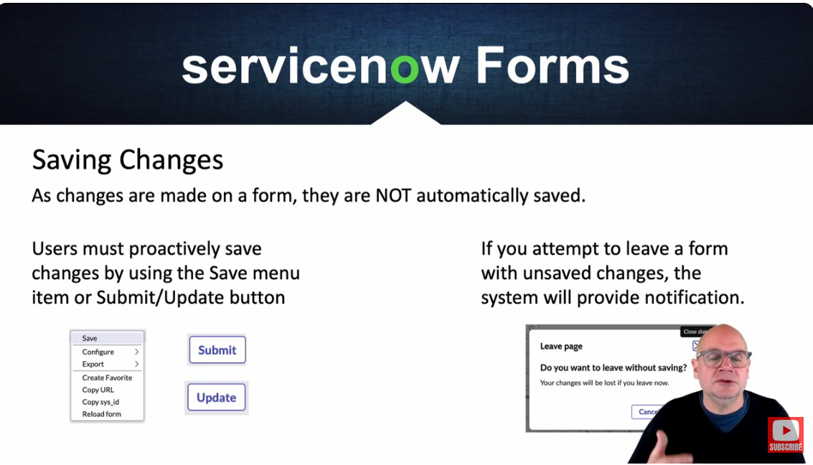

Copying a record

Copying a record can be done using two methods: Insert and Insert and Stay.

**Insert:**

* Purpose**:** Creates a copy of the current record and then immediately closes the form.
* How to Use: After copying, you’re taken back to the list or previous view without staying on the new record's form.

**Insert and Stay:**

* Purpose**:** Creates a copy of the current record and keeps the form open for further modifications.
* How to Use: After copying, the form remains open, allowing you to edit or review the new record.

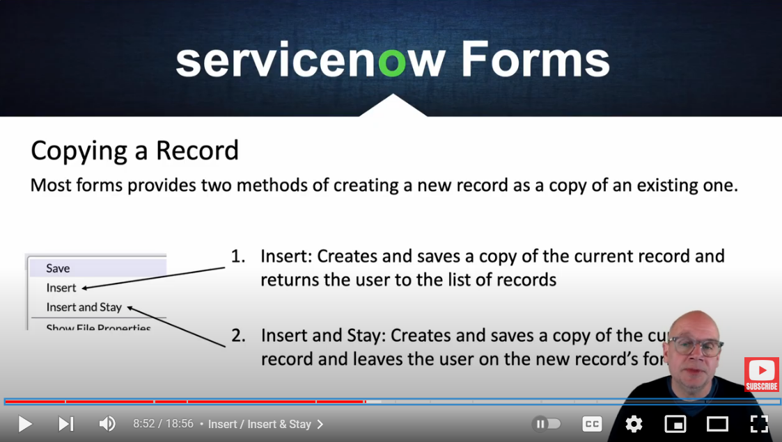

**Form Formatters**

**Formatters** are used to display information on a form that isn't stored as a standard field. They help enhance the user interface by showing additional context or data. Its types are

* Activity Formatter:
  + Purpose: Shows a list of activities or history related to the record. This includes journal entries like comments and work notes.
  + Use: Helps track changes and communications associated with the record.
* Process Flow Formatter:
  + Purpose: Displays the different stages of a process in a linear flow at the top of the record.
  + Use: Provides a visual representation of the record's progress through various stages.
* Parent Breadcrumbs Formatter:
  + Purpose: Shows breadcrumbs indicating the parent or related tasks of the current record.
  + Use: Helps users navigate through hierarchical relationships and see the context of the current task.
* Approval Summarizer Formatter:
  + Purpose: Provides a dynamic summary of the request being approved.
  + Use: Gives a concise overview of the approval request details and status.
* CI Relations Formatter:
  + Purpose: Displays the Configuration Item (CI) form and shows the relationships between the current CI and other related CIs.
  + Use: Helps visualize how different CIs are connected and their dependencies.

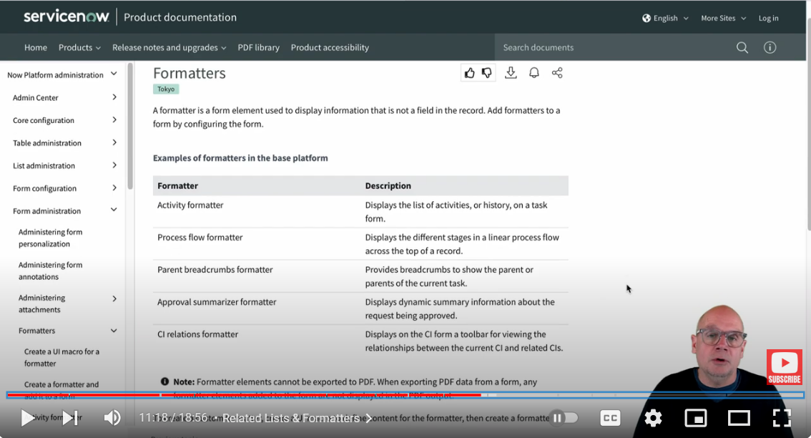**Form Templates**

Form Templates in ServiceNow make it easier to create new records by using pre-set forms with some fields already filled in. This saves time and avoids repeating the same data entry.

* Form Design Tool:
  + A drag-and-drop tool that lets you easily move and arrange fields on a form.
  + Makes it simple to design and change how forms look by letting you place fields and sections wherever you need them.
* Form Layout Device:
  + A tool for managing which fields appear on a form and how they are arranged.
  + Makes it easy to add or remove fields from the form to fit your needs.

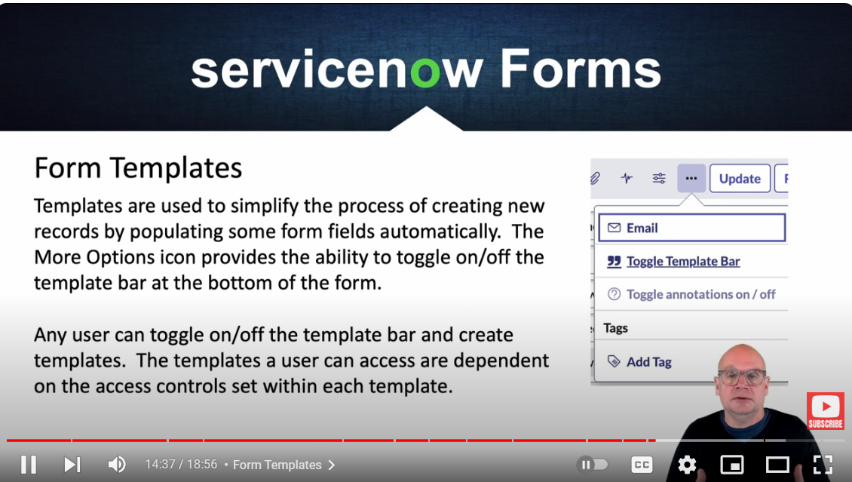

1.7

Key Topics: A Hands-on ServiceNow Tool Demo

Subtopics: Logging In, ServiceNow Next Experience UI, The Navigation Bar, ServiceNow Applications Overview, The Application Navigator, The ServiceNow Store, ServiceNow Application Training and Certifications, Working with Lists and Forms Overview, List Views, Form Views, Knowledge Management in ServiceNow, The ServiceNow Database

ServiceNow is a cloud-based platform designed to automate and streamline organizational processes across various business functions. Initially focused on IT service management, it has evolved into a comprehensive enterprise service management solution that integrates multiple departments such as HR, customer service, security, and finance into a single, efficient workflow system.

Logging In:

1. Open a Browser: Launch your web browser.
2. Enter URL: Type the ServiceNow instance URL into the address bar. This URL usually looks something like <https://yourcompany.service-now.com>.
3. Login Page: You will be directed to the ServiceNow login page.
4. Enter Credentials: Input your username and password.
5. Access Platform: Once logged in, you can access and use ServiceNow's features and tools.

**Next Experience UI**

The **Next Experience UI** is the main interface for ServiceNow applications, designed to be modern and easy to use across different devices.

Navigating the ServiceNow interface using the navigation bar

The Navigation Bar is located at the top of the screen and includes menus for users, notifications, and contextual help. It also features a quick search tool, allowing users to easily find various features across the platform.

The ServiceNow Navigation Bar is a key part of the user interface, providing easy access to various features and tools across the platform. Here’s what it typically contains:

1. **User Menu:**

* This menu allows users to access their profile, preferences, and settings. It also includes options to log out and switch roles if applicable.

1. **Global Search:**

* A quick search bar that lets users find records, applications, and other items across the entire platform. It’s a powerful tool for locating information quickly.

1. **Notifications:**

* This area shows alerts and notifications for tasks, approvals, updates, and other relevant activities. It helps users stay informed about important events and actions.

1. **Contextual Help:**

* This provides users with on-the-spot assistance and guidance related to the page or task they are currently working on. It can include tips, links to documentation, or direct support options.

1. **Favorites:**

* Users can add frequently accessed items to their favorites for quick access. This could include specific applications, modules, or records.

1. **History:**

* This section keeps track of recently viewed items, allowing users to quickly return to them without needing to search again.

1. **Application Menu:**

* The main menu contains links to all the applications and modules available to the user, organized by categories. It’s the primary way to navigate between different parts of the platform.

1. **Bookmarks:**

* Users can create bookmarks for specific pages or tasks they need to access regularly, like web browser bookmarks.

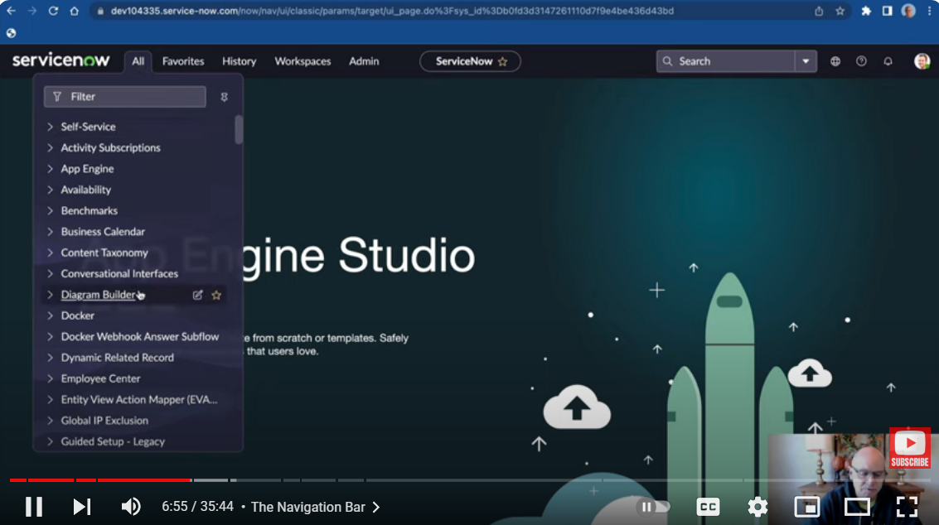ServiceNow Applications Overview

ServiceNow provides a variety of applications that help make business processes easier and more efficient across different departments in an organization. These tools are designed to automate tasks and improve how work gets done.

**Application Navigator**

The Application Navigator in ServiceNow is a key feature that helps users quickly find and access different applications, modules, and features within the platform. It’s typically located on the left side of the screen and serves as the main menu for navigating through the system.

**ServiceNow Store**

The ServiceNow Store is an online shop where you can find, buy, and add extra apps and tools that make your ServiceNow platform do more things. These apps are created by ServiceNow partners, other software companies, or even ServiceNow itself.

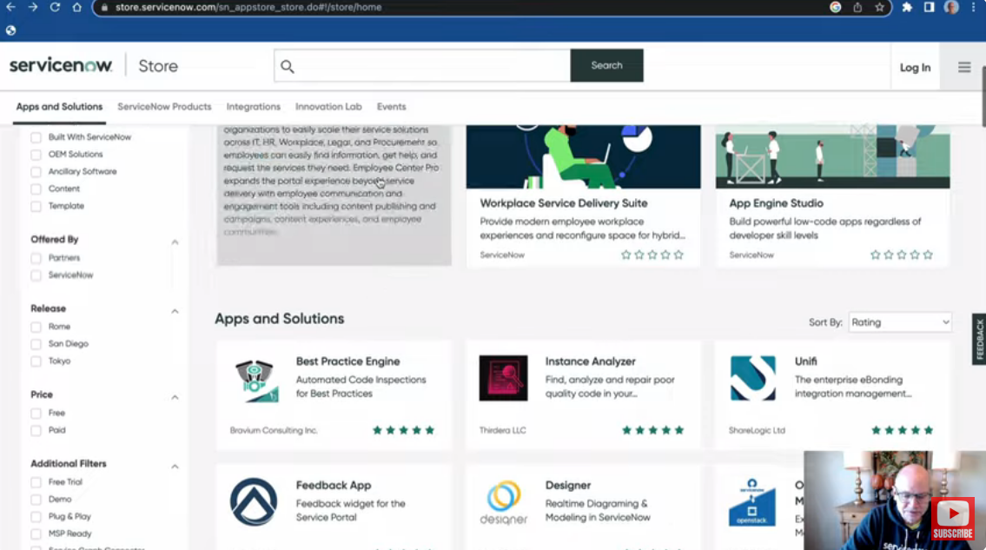 Lists and Forms Overview

Lists and Forms are fundamental components used for viewing and managing data.

### Lists

* Lists display collections of records from a specific table, like incidents or change requests.
  + **Columns:** Lists show various columns of data, which can be customized to display relevant information.
  + **Filtering:** Users can filter and sort the list to find specific records quickly.
  + **Search:** A search bar allows users to find records by keywords or criteria.
  + **Actions:** Users can perform actions on records, such as editing, deleting, or creating new entries.

### **Forms**

* Forms are used to view and enter detailed information about a single record.
  + Fields: Forms contain various fields where users can input, or view data related to the record.
  + Layouts: The layout of forms can be customized to show fields in a specific arrangement based on user needs.
  + Validation: Forms often include validation rules to ensure that the data entered is accurate and complete.
  + Related Lists: Forms can show related lists, which display other records connected to the main record, like tasks or comments.

Knowledge Management in ServiceNow

Knowledge Management in ServiceNow is a module designed to help organizations create, share, and manage knowledge and information effectively. It provides a structured way to handle knowledge articles and ensure that valuable information is readily available to users.

**ServiceNow Database**

The ServiceNow Database is a key part of the ServiceNow platform where all data is stored and organized. It helps keep information structured and easy to access, supporting different applications and processes within the platform.

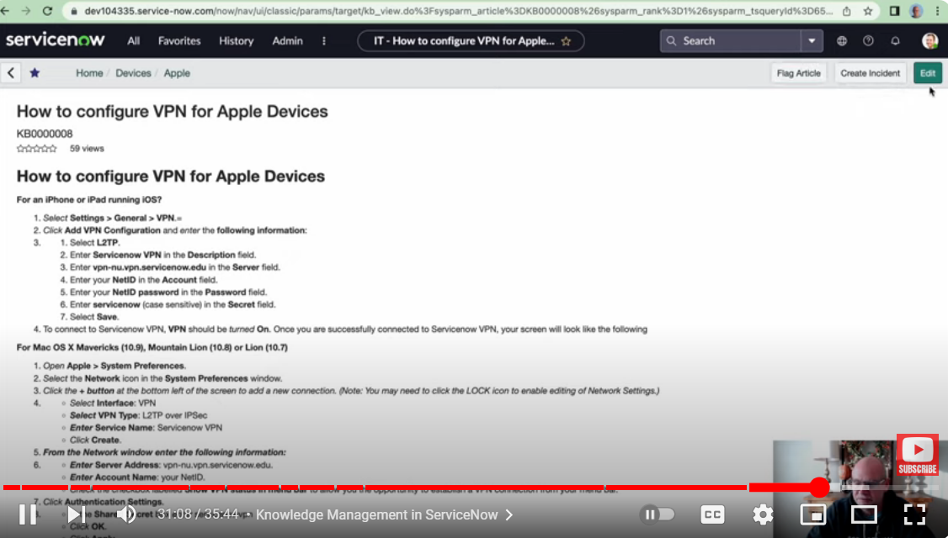1.8

Key topics: Introduction to Importing Data in ServiceNow

Subtopics: import data into ServiceNow via integrations

There are three data entities involved in the import process:

1. The source data
2. The staging table created by ServiceNow
3. The target data store where the data will eventually reside.

Source Data

The entity containing the data to be imported into ServiceNow, ServiceNow is prepared to work with so many sources like Excel, CSV, JSON, JDBC, etc.

Staging Table

A table that ServiceNow created to temporarily store data pulled from source

Target Data

The ServiceNow table into which the data will imported

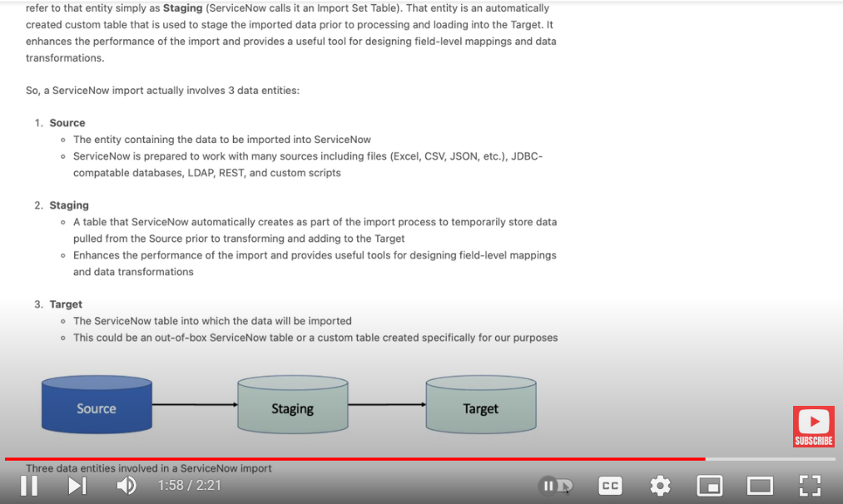

1.9

Key topics: Creating a Data Source in ServiceNow

Subtopics: Integrations in ServiceNow start with the creation of a DataSource, creating a DataSource record in ServiceNow to load data from some external data, collection and importing into the ServiceNow platform

Data Source

A data source refers to a configuration that specifies where and how data is retrieved from or imported into the ServiceNow platform. It defines the connection to an external system or data format and determines how data is brought into ServiceNow for use in tables, reports, or integrations.

* The source sys_data_table stores all data source records, and you can manage these records via the System Import Sets navigation path for easier access and configuration

Creating Data source record

* Go to **All** > **System Import Sets** > **Administration** > **Data Source**.
* Click the **New** button to create a new data source record.

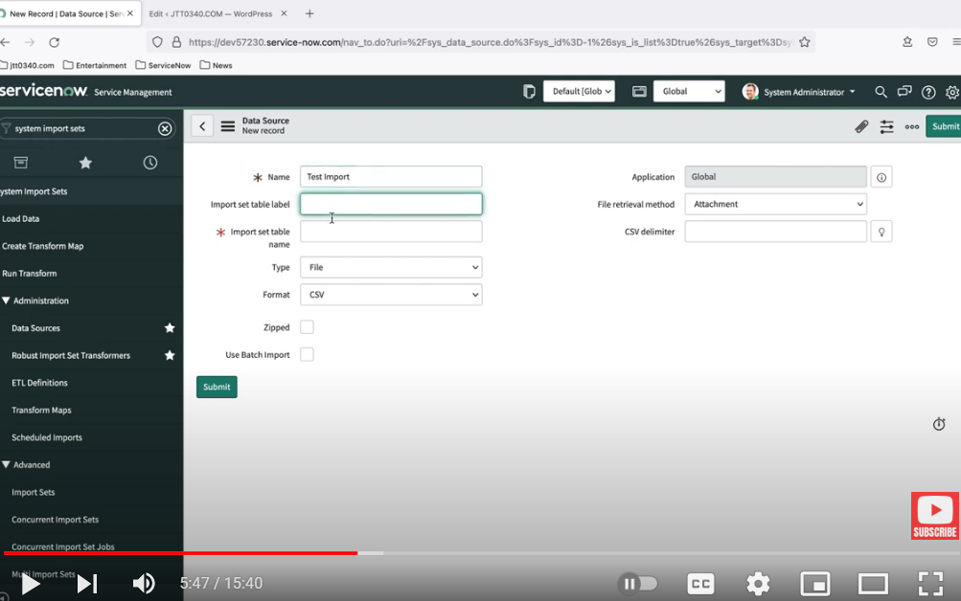

1.10

Key Topics: Understanding Import Sets in ServiceNow

Subtopics: How import sets are created and how they provide the ability to transform data and map individual fields to target tables.

**Import Sets** in ServiceNow are used to import data from external sources into the platform. They provide a way to stage data before it is moved to target tables, allowing for data transformation and field mapping to ensure the data is properly formatted and integrated.

To import data into ServiceNow, we need to follow 5 steps to ensure that the data is properly imported, transformed, and mapped to the correct target tables

### **1. Data Source**

Define the origin and type of data you are importing. This involves setting up a data source that specifies where the data will come from, such as a file, database, or web service.

* + Navigate to **System Import Sets** > **Administration** > **Data Sources**.
  + Create a new data source and configure its details (e.g., file type, connection details).

### **2. Load Data**

Upload the data into an import set table. This step involves loading the data from the defined data source into ServiceNow for initial staging.

* + Navigate to **System Import Sets** > **Import Sets**.
  + Create a new import set record or select an existing one.
  + Click **Load Data** and choose the data file or connect to the data source to upload the data.

### **3. Import Set Table**

Store the imported data in a temporary staging table before transforming it. This table holds the raw data that will be processed.

* + The data you uploaded in the previous step is stored in the import set table. You can view and review the data here to ensure it has been correctly loaded.

### **4. Transform Map**

Define how the data from the import set table should be mapped to fields in the target table. This step involves creating and configuring a transform map that specifies the rules for data transformation and mapping.

* + Navigate to **System Import Sets** > **Transform Maps**.
  + Create a new transform map, specifying the source table (import set table) and the target table (where the data will be moved).

### **5. Transform**

Execute the transform map to move data from the import set table to the target table, applying any transformations and field mappings defined in the previous step.

* + In the transform map record, click **Transform** to start the data transformation process.

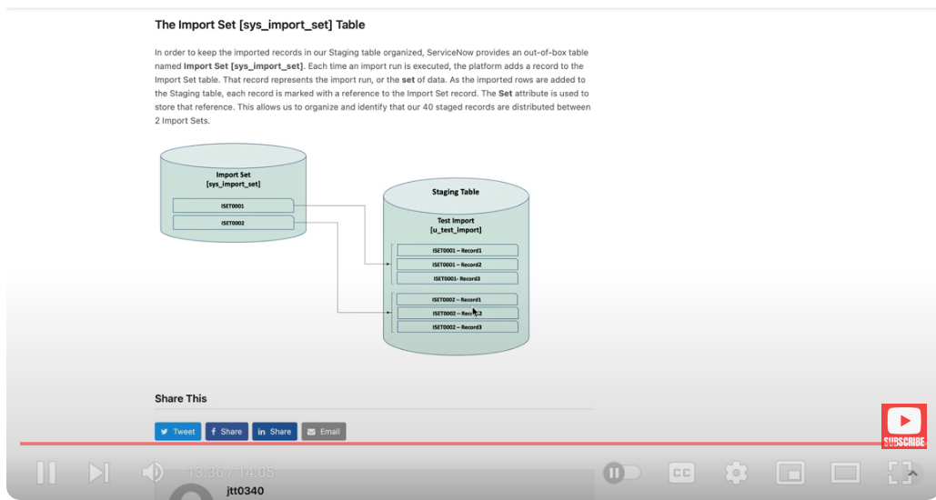

1.11

Key topics: ServiceNow Transform Maps and Transform Fields

Subtopics: Importing, transforming, and mapping imported data into ServiceNow.

Field map

Field Map is an essential component of theTransform Map that defines how data fields from a source table (typically an import set table) are mapped to fields in a target table. This mapping ensures that data is correctly transferred and formatted when moving from the staging area (import set) to the final destination (target table).

* Field maps are stored as records in the 'field map' table (CIS_transform_entry)

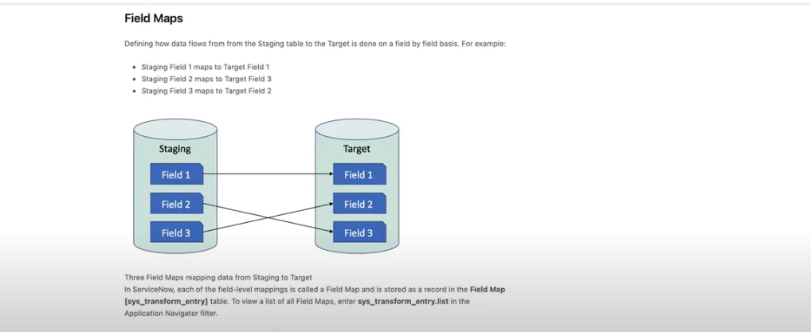

Transform map

* Transform maps group field maps together, representing the import as a whole. They are stored as records in the 'transform map' table (CIS_transform_map).
* The target table for this demonstration is a custom table called 'my_table', created specifically for this purpose.

In ServiceNow, when you work with Transform Maps to move data from an import set table to a target table, there are two primary ways to perform field mapping: the Automatic Mapping Utility and the Mapping Assist Utility. Each method serves a different purpose and offers different levels of control over how fields are mapped.

### **1. Automatic Mapping Utility**

### The Automatic Mapping Utility is a quick and efficient way to map fields between the import set table and the target table when the field names are identical in both tables.

1. Create a Transform Map: Navigate to System Import Sets > Transform Maps and create or open an existing transform map.
2. Click Auto Map Matching Fields: In the transform map, find the related links section and click Auto Map Matching Fields.

### **2. Mapping Assist Utility**

The Mapping Assist Utility provides a more visual and flexible way to manually map fields between the import set table and the target table. It is particularly useful when you need to map fields that don’t have matching names or when you want to map a single source field to multiple target fields

1. Create a Transform Map: Navigate to System Import Sets > Transform Maps and create or open an existing transform map.
2. Open Mapping Assist: In the transform map, scroll down to the Field Maps section and click Mapping Assist.
3. Map Fields Visually: Use the interface to drag fields from the source (import set table) on the left to the target table fields on the right. You can also map one source field to multiple target fields.

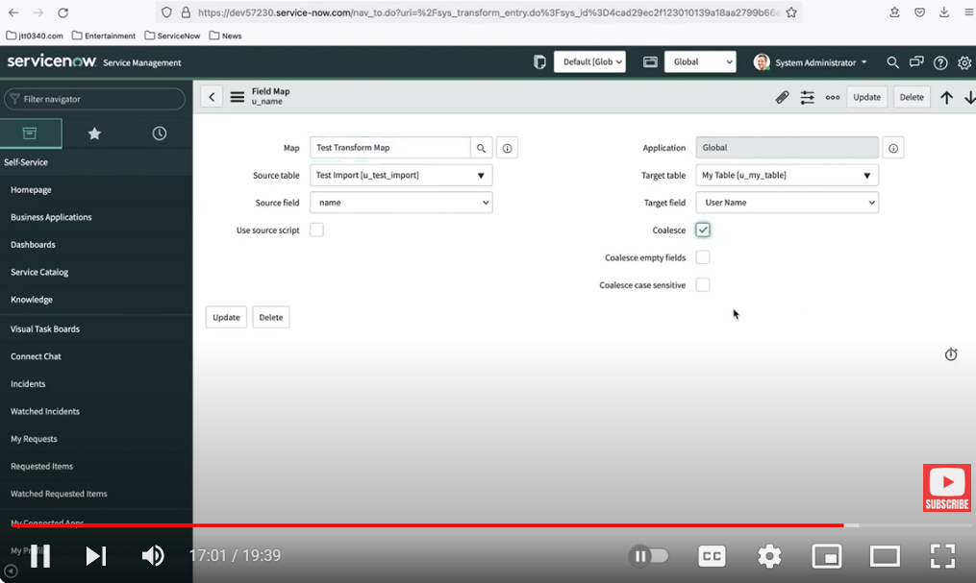

1.12

Key topic: ServiceNow Incident Management Tutorial and Task Administration

Subtopics: ServiceNow ticket and task management (Incident, Problem, Change) capabilities, task creation, task assignment rules, task collaboration, and visual task boards.

TASK

A task is a fundamental record that represents work that needs to be performed. Tasks are central to ServiceNow's workflow and service management processes, allowing organizations to track and manage various types of work efficiently. Tasks can be used in many different applications within ServiceNow, such as incident management, change management, problem management, and more.

* Tasks are stored in a table named 'task'. Users can view all task records by navigating to 'task.list' in the app Navigator.

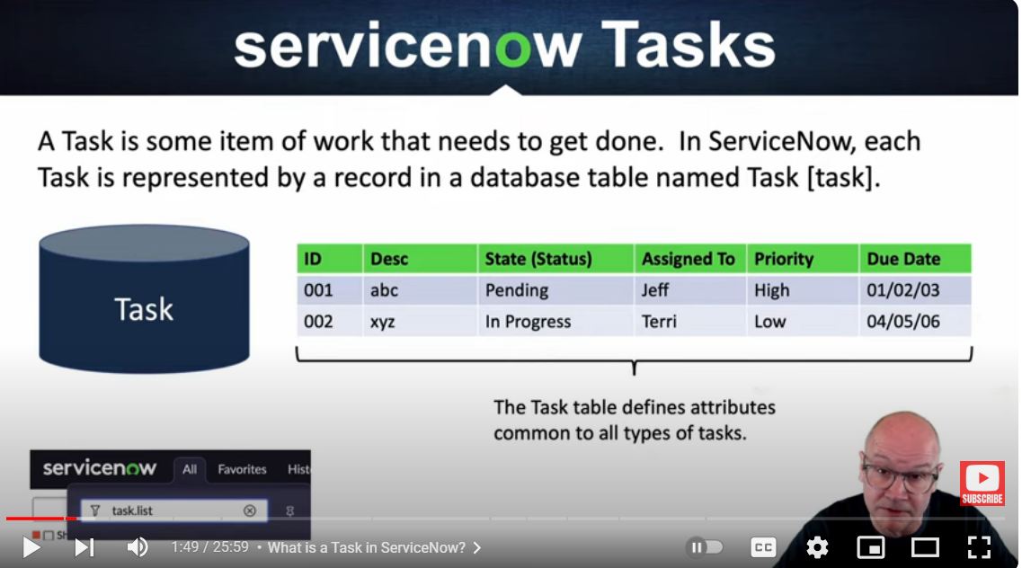

Creating a Task

Creating a task in ServiceNow involves filling out a form with relevant information that will define and manage the task. Tasks can be created manually by a user or automatically through workflows, business rules, or other automated processes.

Depending on the type of task you want to create (e.g., Incident, Change Request, Service Request), navigate to the corresponding module. For example:

* Incident: Go to All > Incident > Create New.
* Change Request: Go to All > Change > Create New.
* Service Request**:** Go to All > Service Catalog > Requests

**Assignment Rules**

Assignment Rules are used to automatically assign tasks to the appropriate user or group based on specific conditions. These rules help streamline the task assignment process by ensuring that tasks are directed to the right people without requiring manual intervention, improving efficiency and consistency in task management.

#### **1. Navigate to Assignment Rules:**

* Go to System Policy > Rules > Assignment Rules.

#### **2. Create a New Assignment Rule:**

* Click on **New** to create a new assignment rule.

#### **3. Fill Out the Assignment Rule Form:**

* **Name:** Enter a descriptive name for the rule (e.g., "Assign High-Priority Incidents to Network Support").
* **Table:** Select the table that this rule applies to (e.g., **Incident**).
* **Active:** Ensure the rule is active so it will be applied.
* **Order:** Set the order in which the rule should be evaluated relative to other rules. Lower numbers are evaluated first.
* **Conditions:** Define the conditions under which the rule should apply. For **Assignment group:** Specify the group to which the task should be assigned if the conditions are met.
* **Assigned to:** Optionally, specify a particular user if the task should be assigned directly to an individual.

#### **4. Save the Rule:**

* After filling in the necessary details, click **Submit** to save the assignment rule.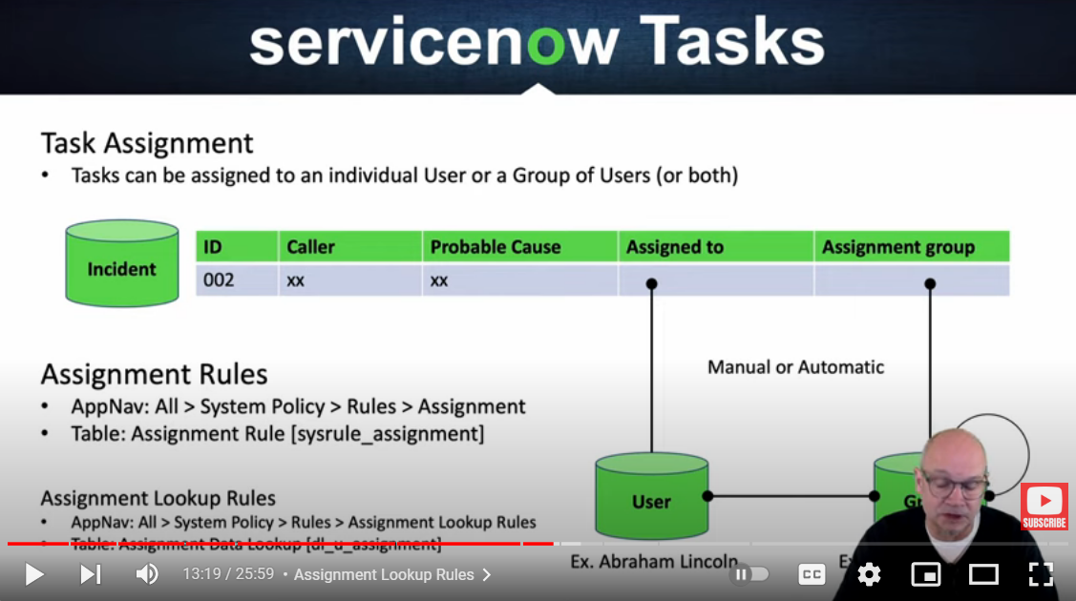

Visual task boards

Visual Task Boards offer a graphical drag-and-drop interface for viewing tasks. They help identify bottlenecks and organize work visually.

**Types of Visual Task Boards:**

* Freeform Board: A flexible board where you can manually create lanes and cards. It’s ideal for personal task management or when you want complete control over how tasks are organized.
* Guided Board**:** This type is linked to a specific table and is driven by a field value. For example, an incident management board might be based on the **State** field of incidents, with lanes representing different states like "New," "In Progress," and "Resolved."
* Flexible Board: Combines features of both freeform and guided boards. It’s linked to a table like a guided board but offers more customization options for how lanes are defined.

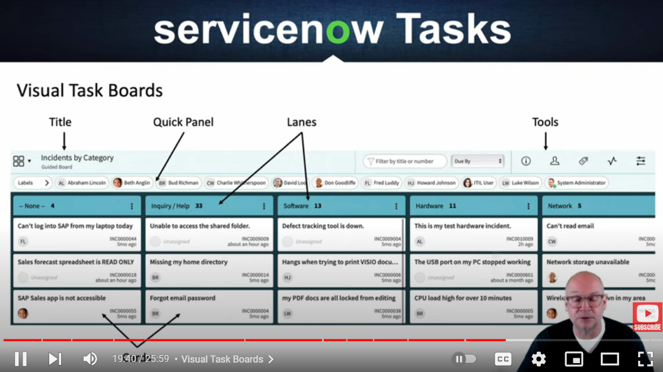

1.13

ServiceNow Reporting

ServiceNow Reporting is a powerful feature that allows users to create, customize, and share reports based on the data stored in the ServiceNow platform. It provides a way to visualize and analyze data, helping organizations monitor performance, track key metrics, and make informed decisions.

* Sys_report - stores all the reports in the instance.
* Report Source - sys_report_source table stores the filters condition of list that are used to populate the report.
* Sys_report_users_groups - used to share reports to groups and tables.
* Dashboard - pa_dashboards used to store multiple reports

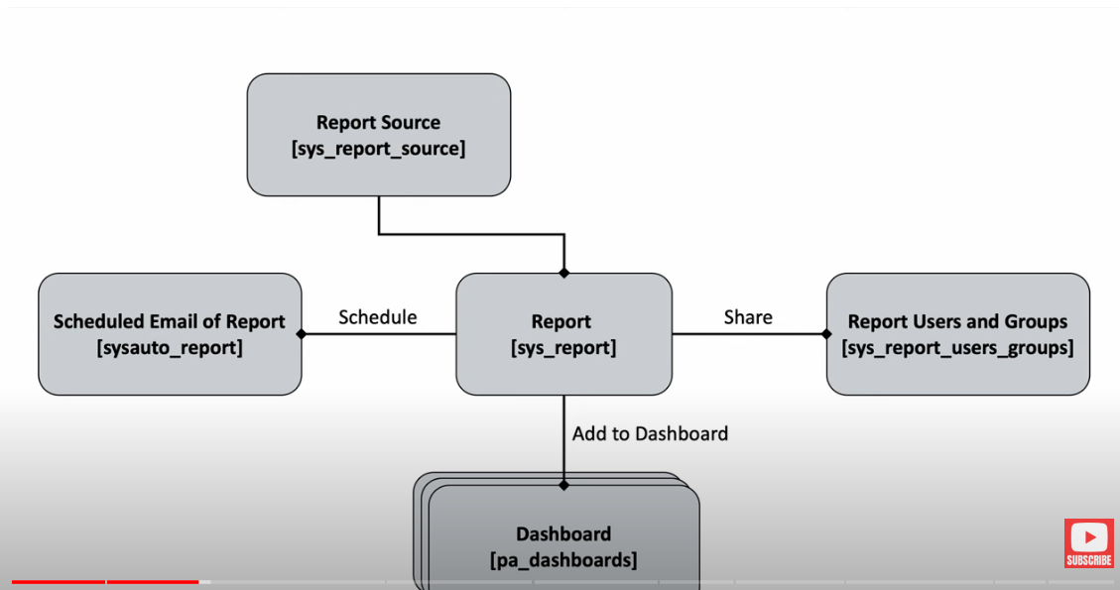

1.14

Key topics: What is Low Code No Code Development?

Subtopics: what Low Code No Code software development, how it works, pros and cons, and career opportunities.

Low Code/No Code Software Development is an approach to software creation that allows users to build applications with minimal or no coding. These platforms provide graphical interfaces and pre-built components, making it easier for non-technical users as well as professional developers to create, modify, and deploy applications rapidly.

### **Pros of Low Code/No Code Development:**

1. **Speed of Development:**

Applications can be developed much faster compared to traditional coding, reducing time-to-market and enabling rapid prototyping and iteration.

1. **Accessibility:**

Non-technical users can build applications, democratizing software development across an organization. This can help bridge the gap between business needs and IT capabilities.

1. **Cost-Effective:**

Reduces the need for large development teams and expensive, highly skilled developers. It also lowers the cost associated with long development cycles.

1. **Flexibility:**
   1. Allows for quick changes and updates to applications without needing to rewrite significant amounts of code, making it easier to respond to changing business needs.
2. **Encourages Innovation:**

By enabling more people to create and test new ideas, organizations can foster innovation and experiment with new solutions more freely.

### **Cons of Low Code/No Code Development:**

1. Limited Customization:

While these platforms offer many pre-built components, they might not provide the flexibility needed for highly customized or complex applications.

1. Scalability Issues:

Some low code/no code platforms may struggle with scaling as the application grows in complexity or user base, leading to performance bottlenecks.

1. Vendor Lock-In:

Applications built on specific platforms may become dependent on that platform’s ecosystem, making it difficult to switch to another platform without significant redevelopment.

1. Security Concerns:

The ease of use may lead to the creation of applications without proper security considerations, which can introduce vulnerabilities if not carefully managed.

1. Integration Challenges:
   1. While many platforms offer integration capabilities, connecting with highly specialized or legacy systems might be challenging and require additional coding or customization.